**Citizen AI:Intelligent Citizen Engagement**

**Platform**

**1. Introduction**

Team leader :[ Vivek vasudevan.R ]

Team member :[ Sham.LV ]

Team member :[ Subramani.R ]

Team member :[ Vijay.M ]

Team member :[ Vishal prabhu.P ]

The City Analysis & Citizen Services AI is an intelligent platform designed to analyze city-level safety data and provide accurate, conversational responses to citizen queries regarding public services, government policies, and civic engagement.

Built with Gradio + FastAPI + LLM (IBM Watsonx Granite), it integrates advanced AI modules such as forecasting, anomaly detection, and multimodal input support, ensuring transparency, efficiency, and ease of citizen interaction.

**2. Project Overview**

This project enables two main functionalities:

City Analysis – Provides reports on crime index, accident statistics, and overall safety.

Citizen Services – Answers citizen queries about government policies, public services, and civic issues.

Additional modules expand the platform into a citizen engagement ecosystem with forecasting, eco-tips, KPI monitoring, and feedback loops.

**3. Conversation Interface**

Built using Gradio Blocks with two main tabs:

City Analysis Tab: Input city name → Output detailed analysis.

Citizen Services Tab: Input query → Output government-style response.

Simple, interactive UI with markdown, textboxes, and buttons.

**4. Policy Summarisation**

AI generates concise summaries of lengthy policy documents.

Helps citizens understand the essence of laws/regulations in plain language.

**5. Resource Forecasting**

Predicts demand for public services (transport, healthcare, electricity).

Supports data-driven governance by preempting shortages.

**6. Eco-Tip Generator**

Suggests personalized eco-friendly lifestyle tips (waste management, water conservation, carbon reduction).

Encourages sustainability awareness among citizens.

**7. Citizen Feedback Loop**

Collects and processes citizen inputs.

AI clusters common complaints and sends them as insightful dashboards to authorities.

**8. KPI Forecasting**

Tracks and forecasts Key Performance Indicators (KPIs) for city governance (pollution, traffic flow, healthcare access).

Generates trend analysis for better decision-making.

**9. Anomaly Detection**

Detects unusual spikes in crime, accidents, or civic complaints.

Triggers alerts for faster government intervention.

**10. Multimodal Input Support**

Future-ready expansion:

Text input (queries, policies).

Image input (accident reports, civic photos).

Audio input (voice-based citizen complaints).

**11. Architecture**

Frontend (Gradio UI)

Simple, interactive conversational interface.

Tabs for different citizen engagement modules.

Backend (FastAPI)

API layer to handle requests between UI, LLM, and ML modules.

Ensures scalability and modular integration.

LLM Integration (IBM Watsonx Granite)

Provides natural language responses.

Used for policy summarisation, query handling, and city reports.

Vector Search (Pinecone)

Stores policy documents, FAQs, civic datasets.

Enables semantic retrieval for accurate responses.

ML Modules (Forecasting & Anomaly Detection)

Uses PyTorch/Sklearn models for time-series forecasting.

Anomaly detection algorithms flag irregular patterns.

**12. Setup Instructions**

Prerequisites

Python 3.9+

GPU (optional, for faster LLM inference)

Accounts for: Hugging Face, Pinecone, IBM Watsonx

Installation Process

# Clone repository

git clone https://github.com/your-repo/city-ai

cd city-ai

# Create virtual environment

python -m venv venv

source venv/bin/activate # Linux/Mac

venv\Scripts\activate # Windows

# Install dependencies

pip install -r requirements.txt

**13. Folder Structure**

city-ai/

│── app.py # Main Gradio app

│── backend/ # FastAPI backend

│ ├── api.py

│ ├── utils.py

│── models/ # ML models (forecasting, anomaly detection)

│── data/ # Datasets & vector DB storage

│── docs/ # Documentation & API references

│── requirements.txt # Dependencies

│── README.md # Project overview

**14. Running the Application**

Step 1: Start Backend

uvicorn backend.api:app --reload

Step 2: Run Gradio App

python app.py

Step 3: Access Application

Open browser → http://127.0.0.1:7860

Use city analysis or citizen services tabs.

**15.screen short:**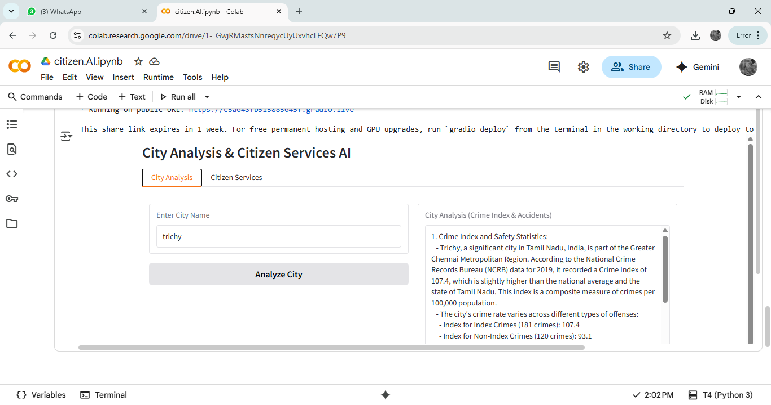

**16.screen short:**

